Mrs. Green’s Gazette:

December 9, 2019

IMPORTANT DATES:
- No School: The holiday break begins at the end of the school day on December 20th. School resumes on Thursday, January 2nd.
- No School: Monday, January 20th (MLK Day)
- Half Day: Friday, January 17th (Professional Development for staff in the pm)
- Late Start Monday’s: School begins at 9:05am and dismissal remains the same
  - December 16
  - January 6, 13, 27
- Specials for the week:
  - Monday: Gym
  - Tuesday: Art
  - Wednesday: Library
  - Thursday: Music
  - Friday: Gym
- PTO Events: Be sure to mention Mason
  - 12/11: MASON NIGHT AT TCBY
  - 12/17: MASON NIGHT AT JETS
  - 1/14 MASON NIGHT AT TCBY
  - 1/21 MASON NIGHT AT JETS
  - 2/17 MASON NIGHT AT JETS
- Holiday Concert: The holiday concert is this Wednesday, December 11th
  - Please see the attached note for important details
  - We will walk over to Parcells in the afternoon of December 11th. Please dress children appropriately for the weather.
- Report Cards Home: December 10th
- Walking Field Trip to Sunrise: December 18th in the afternoon
- Red / Green / Holiday Spirit Day: December 19th
- Holiday Party: Thursday, December 19th beginning at 12:45pm. All are welcome. Please see the sign up to help donate. https://www.signupgenius.com/go/508044DAEAD2BA2FD0-holiday
- Pajama Day: December 20th
- Holiday Book Exchange: During our class Holiday Party, students will participate in a “book exchange.” Each student will be asked to bring in a grade level chapter book to “exchange” with a friend during the class party. The book could be gently used or if new should cost no more than $5.00. If you are unable to find a used book or purchase a new one, please let me know and I can provide one. I love the opportunity for children to participate in gift giving through the use of a good book Please send in a book for the exchange no later than Monday, December 16th. The book should be wrapped and labeled
To: ? From: Your child’s name.

WORD STUDY:
Students will be given the following 5 words and will need to correctly spell them for their quiz on Friday morning. Please practice using these words throughout the week.
Spelling Words: here, other, know, after, some
Challenge Words (only if you want!): Christmas, tradition, sleigh, winter

READING WORKSHOP:
We will continue to focus on describing characters using character traits this week through several mentor texts. As you read at home, talk with your child about the main character(s) in their fiction books and how they might describe them using words like brave, loving, funny, kind, etc.

WRITING WORKSHOP:
We will finish up our Santa’s Stuck in the Chimney stories this week. As we do, we will continue our story writing about Ruldolph’s nose turning green! These are great practice stories for our Grosse Pointe Writing Assessment that takes place in May.

MATH:
We will begin Unit 4 in math this week. In this unit, children will be working on understanding place value and exploring tools and units for measuring length and time. We will begin this week with reviewing how to read clocks. Practice telling time around your house throughout the next few weeks.

SOCIAL STUDIES:
We are continuing our Geography Unit. Ask your child the following questions to review:
- North, South, East, and West are the four _____ directions (cardinal)
- What is a compass rose? (something that shows directions for north, south, east, and west on a map)
- Is Detroit urban, suburban, or rural? (urban)
- Grosse Pointe is located near the city of Detroit, which means we are urban, suburban, or rural? (suburban)
- T or F: A rural area has small communities and lots of open space? (True)

OTHER IMPORTANT INFORMATION:
- Please be sure your child is sent with snow pants, boots, gloves and hats each and every day so they are prepared for any weather!
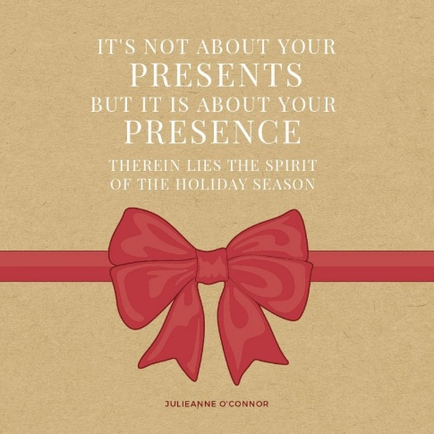
- If you’re interested in being a MYSTERY READER, please let me know what date might work for you!

Your partner in education,
Mrs. Green

